Workout Creation

You will need to click ‘Enable Content’ to enable the full functionality of this document.

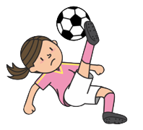

X what is applicable and click submit

|  |  |  |  |  |  |  |  |
| --- | --- | --- | --- | --- | --- | --- | --- |
|  | Soccer | Badminton | Baseball | Track | Football | Tennis | Basketball |
| Love |  |  |  |  |  |  |  |
| Like |  |  |  |  |  |  |  |
| Somewhat |  |  |  |  |  |  |  |
| Dislike |  |  |  |  |  |  |  |
| Hate |  |  |  |  |  |  |  |



Your Workout is…